What are White Blood Cells?
Blood is made up of red blood cells, white blood cells, platelets and plasma. White Blood Cells account for only about 1% of the blood but their impact is big. They are immune system cells also called leukocytes that protect the body against diseases and foreign invaders. In a sense, they are always at war. They flow through the bloodstream to fight viruses, bacteria and other foreign invaders that threaten health. When the body is in distress and a particular area is under attack, white blood cells rush in to help destroy the harmful substance and prevent illness.

While they vary in size, they are generally the largest cell type found in the blood. Among the white blood cells are; Monocytes have a longer lifespan than many white blood cells and help to break down bacteria. Lymphocytes create antibodies to fight against bacteria, viruses, and other potentially harmful invaders. Neutrophils kill and digest bacteria and fungi. They are the most numerous types of white blood cell and the first line of defence when infection strikes. Basophils are small cells that sound an alarm when infectious agents invade the blood. They secrete chemicals such as histamine, a marker of allergic disease, that help control the body's immune response. Eosinophils attack and kill parasites and cancer cells, and help with allergic responses.
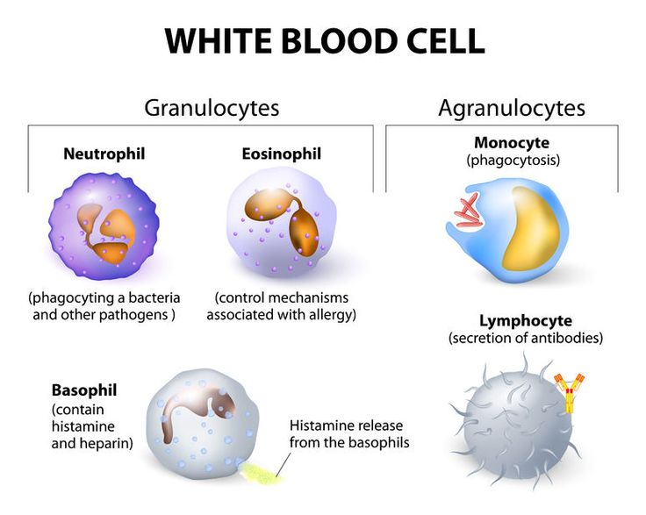

White blood cells are made in the bone marrow and reside throughout the body including in the lymphatic system and in the blood. Because some white blood cells have a short life of 1 to 3 days, your bone marrow is always making them.

Out of all the cells, white blood cells have a nucleus that contain the DNA, RNA and Proteins. In transcription, your genetic code is transcribed or written into RNA. In translation, this RNA is then translated into proteins. DNA makes RNA which in turn makes proteins.

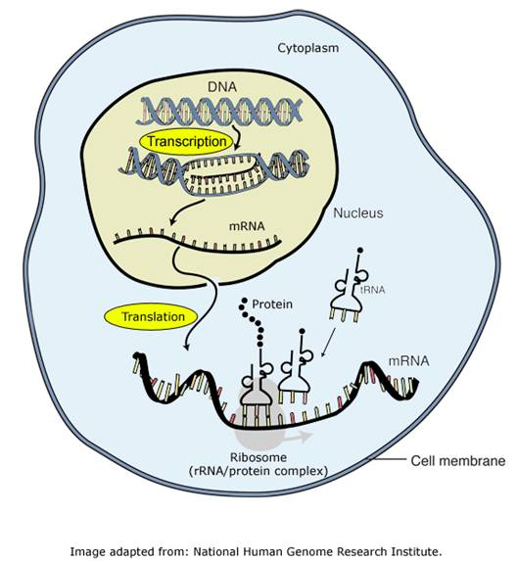
- DNA is the “master blueprint” containing all genetic information. It must be protected and therefore never leaves the nucleus. It has all the instructions or codes that we need to grow, reproduce and function.
- RNA is the “temporary blueprint” that copies instructions or small portions of DNA and can leave nucleus to synthesize proteins at the ribosome. Plays an active role in Transcription and Translation.
- Proteins are the primary building blocks of life known as amino acids. There are 20 amino acids in our standard genetic code. They all serve important roles in our growth, development and everyday functioning.
https://www.stanfordchildrens.org/en/topic/default?id=what-are-white-blood-cells-160-35
https://www.sciencelearn.org.nz/resources/209-role-of-proteins-in-the-body
SarsCov-2 Injections
1. Oxford-AstraZeneca Adenoviral Vector (Other Viral Vectors: Janssen (Johnson & Johnson), Sputnik V and Ad5-nCoV (Convidecia))
Following injection, solution goes into the bloodstream, into the white blood cells releasing the genetic piece that codes for Sars-Cov-2 spike proteins into the cell nucleus. Transcription takes place where the code for the Sars-Cov-19 spike protein is transcribed into mRNA, mRNA copies instruction and goes out from the nucleus into the cytoplasm. mRNA attaches to the ribosome where translation takes place to produce the spike proteins. Spike proteins (antigen) are recognised as foreign bodies and triggers white blood cells to produce antibodies.
Pharmacology Reference from Wikipedia: Following vaccination, the adenovirus vector enters the cells and releases its genes, which are transported to the cell nucleus; thereafter the cell's machinery does the transcription into mRNA and the translation into proteins.
2. mRNA (Pfizer-BionTech and Moderna)
Nucleoside-modified mRNA (modRNA) encoding a mutated form of the spike protein of SARS-CoV-2, encapsulated in lipid nanoparticles in a solution. Following injection, solution goes into the bloodstream, into the white blood cells, in the cytoplasm. Modified mRNA attaches to the ribosome where translation takes place and produce the spike proteins. Spike proteins (antigen) are recognised as foreign bodies and triggers white blood cells to produce antibodies.
3. Protein Subunit (EpiVacCorona and ZF2001(RBD-Dimer)
Spike Protein encapsulated in lipid nanoparticles in solution. Following injection, encapsulated Spike proteins goes in the bloodstream and into white blood cells. Spike proteins (antigen) are recognised as foreign bodies and triggers white blood cells to produce antibodies.

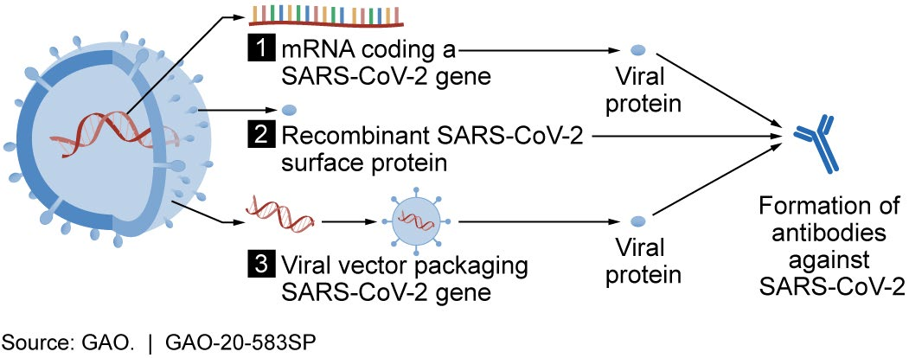

4. Inactivated SarsCov-19 Vaccines (CoronaVac/Sinovac, CoviVac, BBV152(Covaxin) and BBIBP-CorV(Sinopharm)
Following vaccination of the Inactivated SarsCov-19 virus, solution goes inside the bloodstream. Some of the inactivated viruses are swallowed up by a type of white blood cells called lymphocytes specifically the T cells. The T cells tears the coronavirus apart and displays some of its fragments on the cell’s surface. B cells another type of lymphocyte gets activated and produce antibodies in response, to disable or mark pathogens for destruction. The next time the body is exposed to the same specific virus, the body will recognise and produce antibodies.

